AAI-540 ML Design Document

Team Info
Project Team Group #: AAI-540 Group 4
Authors: Ali Azizi, Divya Kamath, Gaius Thomas
Business Name: Diabetes Patient Readmission Prediction Using MLOps
Publication Date: TBD (Tentative Last week of May)

Team Workflows
GitHub Project Link:
https://github.com/al1az1z1/AAI-540-Diabetes-Readmission-MLOps

Asana Board Link: https://app.asana.com/1/952672460738672/project/1214877183011677/list/1214877183334443

Team Tracker Link:
https://docs.google.com/document/d/1i2Hg6AaqYmu7XyaHaoTc8nP-zjQn-Sdd1tcTvo25AR4/edit?tab=t.0

Project Scope
Project Background:

Preventable hospital readmissions are a significant problem in the healthcare sector, particularly with those who have diabetes. Unplanned hospital readmissions are costly, add to the burden on hospitals and can be a sign of inadequate post-hospital care. With the increasing pressure on hospitals to find data-driven solutions that can be used to identify high-risk patients before they leave the hospital, early interventions and follow-up care are available.

This project will develop a machine learning classification system to forecast if a diabetic patient is at risk for readmission within the 30-day window following his/her discharge from the hospital based on prior hospital encounter data. The goal of the model is to help healthcare providers enhance the quality of care for patients and minimize preventable readmissions and the costs of those readmissions. This project is tasked with solving a supervised machine learning classification problem, which involves the model predicting if a patient is at risk of being readmitted to the hospital based on patient demographic, diagnosis, medication, lab information and hospital visit data. The project also includes common MLOps principles like automated pipelines, model monitoring, CI/CD workflows, and scalable deployment, to mimic a practical healthcare machine learning system.

Technical Background:

The model is assessed by technical aspects and business aspects. Accuracies, precisions, recalls, F1 score, and ROC-AUC are the key evaluation measures from a machine learning point of view. In a Health Care setting, with a focus on identifying high-risk patients, the importance of decreasing the false negative, (at risk patients, classified as Low Risk) is given attention with a focus on Recall and F1-Score. The project highlights the potential of predictive analytics in the healthcare sector, showing how it can be used to lower readmission rates, improve patient care coordination, and optimize resource use from a business standpoint.
The project is based on the UCI Diabetes 130-US Hospitals Dataset with over 100,000 patient records from 130 hospitals across the United States from 1999 to 2008. Patient characteristics, medical diagnosis, medications, laboratory services, hospitalizations and readmission status. Data preparation involved addressing the data missingness, encoding the categorical data, selecting the relevant features, and balancing the class data. Visualizations and statistical summaries were used to perform Exploratory Data Analysis (EDA) to look for trends, correlations, feature distributions, and possible data quality problems.

During the initial exploratory modeling phase, Logistic Regression and XGBoost were evaluated for the project. Therefore, Logistic Regression was used as the baseline model and XGBoost was chosen as the main production model, as it outperformed the baseline model across most evaluation metrics and was ultimately selected for implementation in the automated SageMaker Pipeline.

Goals vs Non-Goals:

Goals:
- Build a production-grade machine learning system to predict the risk of hospital readmission for diabetic patients.
- Develop and evaluate multiple machine learning models, including Logistic Regression and XGBoost, and select the best-performing model for production deployment.
- Construct an end-to-end MLOps pipeline using AWS SageMaker that includes data ingestion, feature engineering, model training, evaluation, model registration, batch deployment, monitoring, and CI/CD automation.
- Achieve strong predictive performance with emphasis on recall and F1-score to effectively identify high-risk patients.
- Implement automated CI/CD workflows, model versioning, and CloudWatch monitoring dashboards to simulate real-world ML system operations.

Non-Goals:
- Building a clinically approved diagnostic system for real-world medical decision-making.
- Achieving state-of-the-art predictive performance or research-level accuracy.
- Integrating with real hospital information systems, electronic health record (EHR) platforms, or live clinical data streams.
- Developing a deep learning or highly complex neural network solution requiring large-scale GPU infrastructure.
- Creating a patient-facing healthcare application or mobile interface.

Solution Overview
ML System Summary:
The end-to-end MLOps pipeline that is being implemented here aims to predict the risk of hospital readmission for diabetic patients over the next 30 days using the UCI Diabetes 130-US Hospitals dataset. The system leverages Amazon S3, AWS Glue, Amazon Athena, SageMaker Feature Store, SageMaker Pipelines, SageMaker Model Registry, Batch Transform, and CloudWatch. S3, Athena, and Feature Store are used in the EDA/data engineering workflow, while SageMaker Pipelines automates preprocessing, training, evaluation, model registration, batch inference, and monitoring.
The final flow is an automated SageMaker Pipeline that processes the data for preprocessing, trains the model, evaluates it, registers the model, and performs batch inferences. The models are assessed by accuracy, precision, recall, F1 score and ROC-AUC, and registered and deployed if the F1 score is above a predetermined threshold. The output of the prediction and quality metrics of the models are saved and tracked using AWS services to enable a production style machine learning workflow.

System Architecture:
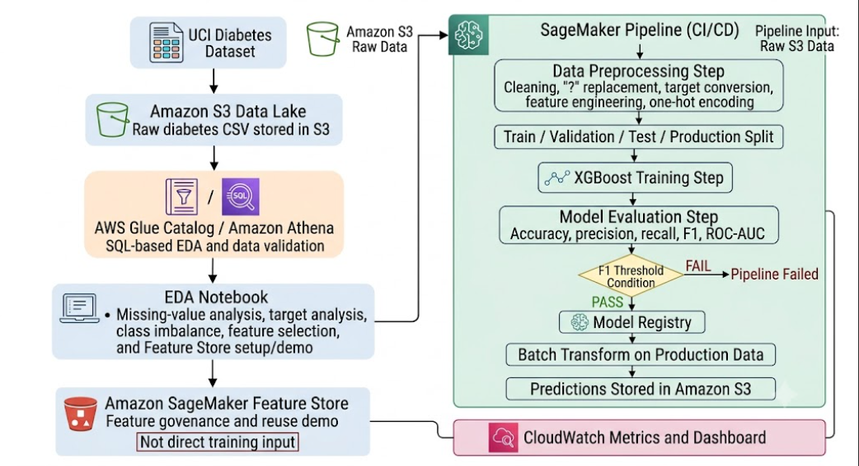
Note: During exploration, a real-time SageMaker endpoint was also implemented and tested to validate online inference, endpoint monitoring, and data capture capabilities.

Data Sources:

What is your data source?
We will use the UCI Diabetes 130-US Hospitals Dataset from the UCI Machine Learning Repository.

What is your data volume?
The dataset spans more than 100,000 patient encounters across 130 hospitals in the United States from 1999 to 2008, and comprises around 50 different features, including details about the patient, diagnoses, drugs, and hospital visits.

Why did you select this data set?
We chose this dataset because it was well-suited for the scope of our MLOps project. It contains real healthcare data for our prediction problem of hospital readmission. It has a diverse mix of features related to demographics, clinics, and treatments. It was also large enough for data engineering, feature engineering, model training, monitoring, and CI/CD.
Any risks (bias, sensitive features, etc)?
There are certainly risks associated with the dataset. For example, sensitive features include gender, race, and age. These are typically protected demographics that have the potential to introduce fairness concerns. As always, historical healthcare disparities may also be reflected in the data, and the model could learn unfair patterns that affect minority groups. The notebook intentionally excludes unique patient identifiers to reduce privacy risk. Fairness risks were considered because race, gender, and age are included in the dataset. SageMaker Clarify and bias monitoring are identified as future enhancements for a more complete production version.

Data and Feature Engineering:
As mentioned above the original dataset was loaded locally as “diabetic_data.csv” and uploaded to an S3 bucket. An Athena database and external table was created to allow SQL queries and exploratory analysis without having to move the data.
As for preprocessing, we transformed the original target variable which had three classes to a binary classification problem that distinguished patients who had readmitted within thirty days to those who were not readmitted in thirty days. We also used a subset of clinically relevant features including race, gender, age, admission information, hospital utilization metrics, lab results, and diabetes medication information. We removed “patient numbers” and “encounter id” as they were unique identifiers. We applied one hot encoding to categorical variables like race, gender, age, etc. to make the data compatible with later steps. We also had some basic cleaning and alignment like converting Boolean values to 0 and 1, replacing missing values, converting all model inputs to numeric types, and aligning the features to a consistent schema.
Feature Store was implemented as a governance and feature reuse layer, but the final automated training pipeline does not train directly from Feature Store. Instead, the SageMaker Pipeline reads the raw dataset from S3 and applies the same feature engineering logic inside the preprocessing step (The dataset is static and we only have one model so here feature Store adds complexity without much benefit unless we have multiple models in the same business domain).

Training Data:

How will you split your data into training, test, and validation?
The full dataset is first sampled using stratified sampling to create a cost-efficient development dataset of 15,000 records. The dataset is divided in such a way that 80% is for training, 10% for validation, and 10% for testing. Moreover, a distinct production set comprising 6,000 new, unseen records are reserved for batch inference, deployment validation, and monitoring.
Will you use any data labeling techniques?
Manual data labelling is not necessary because the data set contains an outcome column of readmitted. The actual values are converted to a binary classification: <30=1, NO and >30=0, which indicates that the patient was readmitted within 30 days (1) or not readmitted to patient within 30 days (0).

Model Training & Evaluation
Logistic Regression was used during exploratory modeling as a baseline benchmark. The final automated SageMaker Pipeline uses XGBoost as the champion-candidate model for predicting 30-day hospital readmissions. The pipeline automates preprocessing, training, evaluation, model registration, and batch inference decisions through SageMaker Pipelines. Model performance is exported to evaluation reports and used by a pipeline condition step to determine whether a model version can be registered and approved for batch deployment. The XGBoost model is trained using hyperparameters selected to address class imbalance and achieve strong predictive performance on structured healthcare data. Model performance is evaluated using accuracy, precision, recall, F1-score, ROC-AUC, and confusion matrix metrics, with particular emphasis on recall and F1-score because correctly identifying high-risk readmission cases is critical in healthcare settings. Models that meet the required F1-score threshold proceed to model registration and batch inference, while models that fail to meet the threshold are automatically rejected by the pipeline.

Model Deployment
Automated deployment using SageMaker Pipelines. Once the model is evaluated successfully, it is registered in the Model Registry of SageMaker and is then used to run a Batch Transform job over the reserved production dataset. This way, the cost of infrastructure can be lowered and the workflows for production deployments can be shown. A real-time SageMaker endpoint was also developed and tested for online inference, endpoint monitoring, and data capture during the development. Nevertheless, the last production workflow, along with the deployment of CI/CD, relies primarily on Batch Transform because it reduces operational costs and aligns with the healthcare batch-scoring use case.

Model Monitoring
Model monitoring is implemented through Amazon CloudWatch custom metrics, dashboard visualization, and SageMaker Pipeline execution history. After each successful pipeline execution, evaluation metrics generated in evaluation.json are published to CloudWatch under the project namespace. The monitoring dashboard tracks accuracy, precision, recall, F1-score, and ROC-AUC across model and pipeline versions. Infrastructure monitoring includes tracking pipeline execution status, processing job failures, training job failures, Batch Transform execution results, and CloudWatch logs. Batch prediction outputs stored in Amazon S3 are also reviewed to verify successful inference and output generation. Full automated drift detection was not implemented in this project but could be added in future work using SageMaker Model Monitor for data drift, prediction drift, and model performance monitoring.

Model CI/CD
What checkpoints will your CI/CD pipeline contain?
The SageMaker Pipeline contains the following checkpoints:
- Data preprocessing and feature engineering completion.
- Successful training of the XGBoost model.
- Model evaluation on the test dataset.
- Automated F1-score validation using a pipeline condition step.
- Model registration in the SageMaker Model Registry.
- Batch Transform inference on the reserved production dataset.
- Publication of model quality metrics to Amazon CloudWatch.
If the model is not able to achieve the specified F1-score threshold, the pipeline goes to failed state and deployment is not allowed. All pipeline executions, including successful and unsuccessful, are stored to be audited and reviewed.
What tests will your CI/CD pipeline contain?
Before releasing a new model version, the pipeline performs several validation tests, including:
- Verification of data quality and schema consistency.
- Validation of preprocessing and feature engineering outputs.
- Training, validation, and test dataset generation.
- Evaluation of model performance using accuracy, precision, recall, F1-score, and ROC-AUC.
- Validation that Batch Transform executes successfully on production data.
- Automated F1-score threshold testing to determine deployment eligibility.
Only models that satisfy the required evaluation criteria proceed to model registration and batch deployment.

Security Checklist, Privacy and Other Risks:
Will this store or process Personal Health Information (PHI)?
No
Will this store or process Personal Identifiable Information (PII)?
No
Will user behavior be tracked and stored?
No
Will this store or process credit card information?
No
If you answered yes to any of the above questions, please justify.
The UCI Diabetes dataset is a de-identified public research dataset. No direct patient identifiers
What S3 buckets will this application read from or write to?
s3://aai540-diabetes-readmission-<account-id>
What data bias should be considered?
- Race
- Gender
- age
Will your model have potential for bias along sensitive features (race, ethnicity, gender, age, religion, disability, sexual orientation, or other personal attributes)
Yes. Information on race, gender, and age is included in the data set, and this might lead to biases or unequal model performance among patient populations.
Are there any ethical concerns with the data or business problems that should be addressed?
Yes. Using the model to make decisions is not a substitute for the clinician's judgment. Healthcare applications should be monitored for potential bias, prediction errors and fairness.
Future Enhancements:
- Automate retraining with new hospital encounter information.
- Use monitoring to validate models automatically and then promote them to production as a part of the CI/CD pipeline.
- Deploy real time endpoints and infer online for hospital decision support systems.
- Measure model performance by race, gender and age groups with a full fairness evaluation using SageMaker Clarify.
- Train future model versions directly from the SageMaker Feature Store offline store to improve feature reuse and training/inference consistency.
- Use the entire 100,000+ records data set to train and validate the model, gaining greater confidence in the model.

